**PROJECT REPORT**

**Information Systems Design & Development**

**PACE ONLINE EXAMINATION SYSTEM**

**SUBMITTED BY:**

**Yash Shah**

**Mallika Singh**

**Manthan Shah**

**Akanksha Gupta**

**Yashwant Rao**

**PROJECT SCHEDULE (Appendix D)**

**Gantt chart**

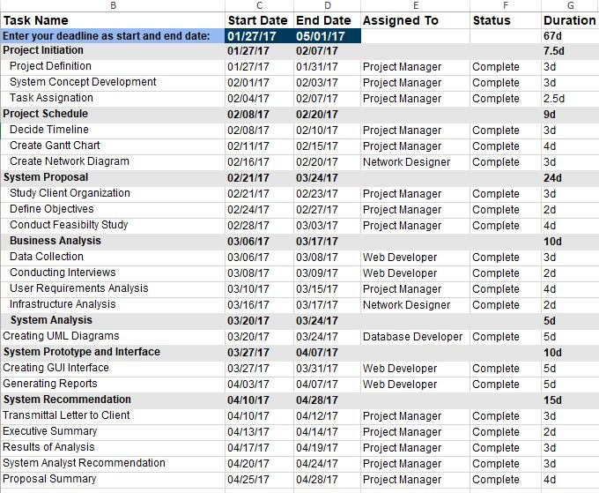

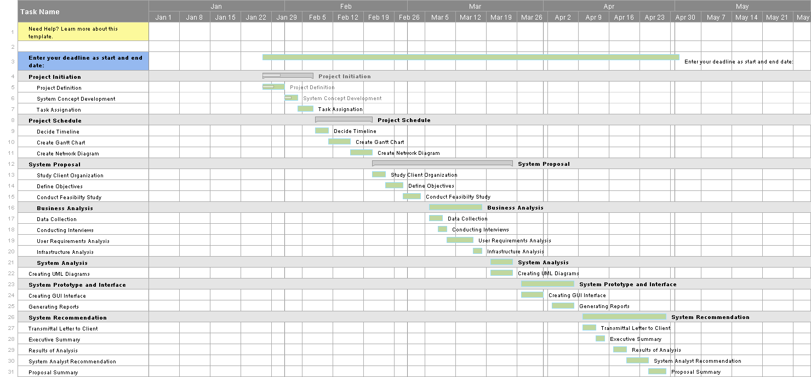

**Network Diagram**

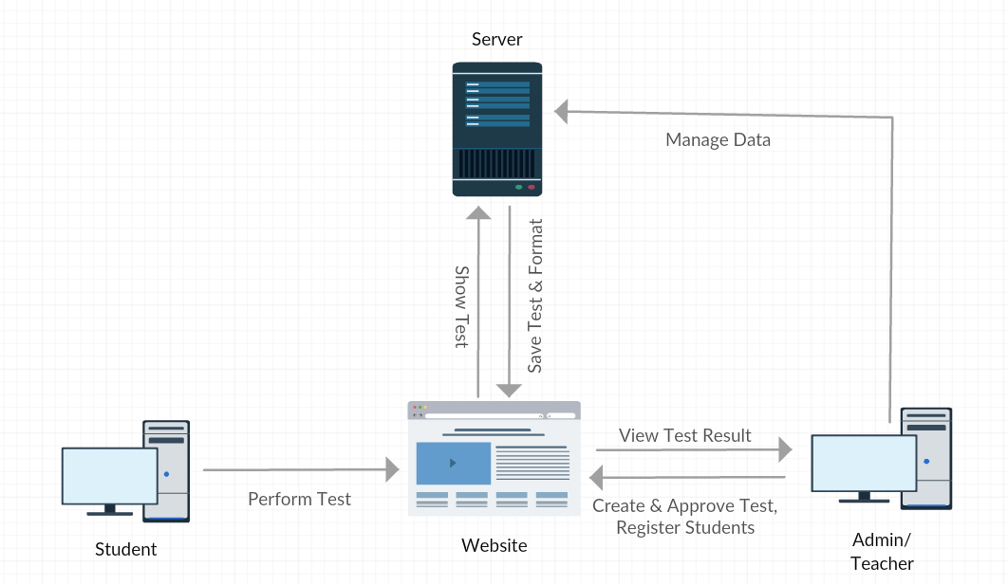

**SYSTEM PROPOSAL (Appendix A)**

**Service Request**

1. **Name of Client Company or Organization:** Pace University

**Address:** One Pace Plaza, New York, NY, 10038

**Line of business:** Education

**Company contact:**

**Contact's phone number:** 866-722-3338

**Contact's e-mail address:** [onepaceplaza@pace.edu](mailto:onepaceplaza@pace.edu)

1. **Description of how the project was initiated**

*Pace Online Exam System (POES)* is being launched because there is a need for a platform that is beneficial for both the University and the students. With this site, professors can register students and host online exams. Students can give exams and view their results. Hence, this website is an attempt to remove the existing flaws in the manual system of conducting exams.

1. **Description of the problem/opportunity to be investigated**

*Pace Online Exam* *System* fulfills the requirements of the University to conduct exams online. They just have to register on the site and enter the details of the students who can appear in the exam. Students can give exam without the need of going to any physical destination. They can view the results at the same time. Thus, the purpose of the site is to provide a system that saves the efforts and time of both the University and the students.

1. **Anticipated business benefits**

The purpose of the *Pace Online Exam System* is to take online tests in an efficient manner so that no time is wasted on checking papers. The main objective of the Pace Online Exam system is to efficiently evaluate the candidate thoroughly through a fully automated system that not only saves a lot of time but also gives fast results. Moreover, there is no restriction that the examiner has to be present while the candidate is taking the test.

1. **System capabilities**

*Pace Online Exam* *System* is a web application that establishes a network between the University and the students. The professors can enter on the site the questions they want in the exam. These questions are displayed as a test to the eligible students. The answers entered by the students are then evaluated and their score is calculated and saved. This score can then be accessed by the institutes to determine the number of students that passed or failed and to evaluate their performance.

1. **Personnel (employees & managers)**

There are mainly 2 types of personnel present in the system- the professor that acts as an administrator and the students that will be taking exams.

1. **Organization chart for the related part of the organization**

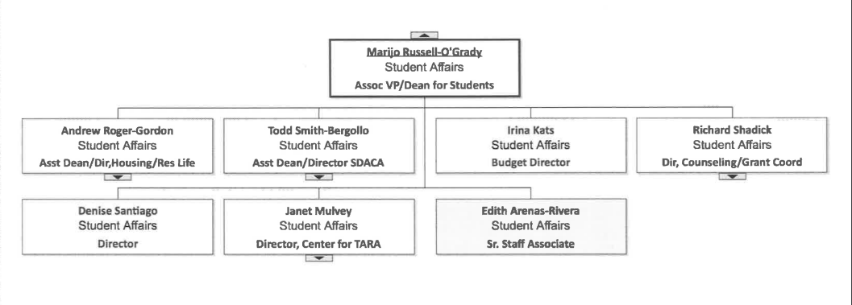

**Objectives**

1. **Statement of the mission/goal of the organization**

This Web Application provides the University the opportunity to conduct examinations online. It saves time as it allows the number of students to give exams at a time when the professor makes it available and displays the results when the test gets over. There is no need to wait for the result as it is automatically generated by the server.

1. **Measurable Objectives for the proposed system**

* In comparison to the present system the proposed system will be less time consuming and more efficient.
* Analysis will be very easy in proposed system as it is automated
* Result will be very precise and accurate and will be declared in a very short span of time because calculation and evaluations are done by the simulator itself.
* The proposed system is very secure as there are no chances of leakage of question paper as it is dependent on the administrator only.
* The logs of appeared candidates and their marks are stored and can be backup for future use

**Feasibility Study**

1. **Technical Feasibility**

The technically feasibility study centers on the alternatives for hardware, software and the design approaches to determine the functional aspects of the system. This project on Online Examination will be platform independent. PHP is used to create web pages. MySQL database will be used for storing data. Hardware requirements used are compatible with all operating systems. Only authorized person would be able to use the website so it would be secure. The system can also be expanded as per the needs of requirement specification.

1. **Economic Feasibility**

Economic analysis is most frequently used for evaluation of the effectiveness of the system. More commonly known as the cost/benefit analysis, the procedure is to determine the benefit and savings that are expected from a system and compare them with costs, so that decisions can be made to design and implement the system. This part of feasibility study gives the top management the economic justification for the new system. This is an important input to the management. If the organization implements this system, it does not need any additional hardware resources as well as it will be saving a lot of time.

<EconomicAnalysis.xls>

As can be seen from the above Cost/benefit analysis document, the benefits of implementing the system outweigh the costs.

1. **Operational Feasibility**

Operational Feasibility is a measure of how people are able to work with the system. This type of feasibility demands if the system will work when it is developed and installed. Since this website is very user friendly, the users will be comfortable using this site.

1. **Schedule Feasibility**

The schedule feasibility guarantees that the implementation of the system is completed on time. The system is time-feasible as the time required for generating a report or for doing any other work will be comparatively very less as compared to the existing system. Also, record finding and updating will take lesser time as compared to the existing system.

**BUSINESS ANALYSIS (Appendix B)**

**Conduct of Analysis**

1. **Analysis methods used**

Requirements analysis encompasses those tasks that go into determining the needs or conditions to meet for a new or altered product, taking account of the possibly conflicting requirements of the various stakeholders such as beneficiaries or users. The analysis methods included three types of activities:

* Eliciting requirements: The task of communicating with customers and users to determine what their requirements are. This is also known as requirements gathering.
* Analyzing requirements: Determining whether the stated requirements are unclear, incomplete, ambiguous, or contradictory, and then resolving these issues.
* Recording requirements: Requirements may be documented in various forms, such as natural-language documents, use cases, user stories or process specifications.

1. **End-users contacted**

It is important to identify all the stakeholders, take into account all their needs and ensure they understand the implications of the new system. The end-users contacted were mostly students and faculty using the existing examination system. They were interviewed in order to analyze what are the problems they were facing with the existing system and how we can incorporate changes to make our Online Examination system more efficient and user-friendly.

1. **Records, forms and reports analyzed**

Several techniques were used to elicit requirements from the customers. This included holding interviews, and holding focus groups (more commonly known as requirements workshops) and creating requirements lists. Also, techniques such as prototyping and use cases were also used. Where necessary, we employed a combination of these methods to establish the exact requirements of the stakeholders, so that a system that meets the business needs can be produced.

1. **Processes Observed**

The various processes in the Online Examination system are:

* Login
* The faculty (who acts as an admin) as well as the students can login with their valid registration ID and password. Only authenticated users are granted access to the system.
* Registration
* The admin can register students which can take the exam by providing their details. Once a student is registered, he can login into the system by providing his registration ID and password.
* Test
* Once the student clicks on the “Begin Exam” option his test will begin once it is made available by the admin. 20 multiple choice questions will be available to the students out of a random selection of 100 questions. The student can attempt the questions in any order but it is mandatory to answer all the questions.
* Result
* When the test is over, the student can click on ‘Submit Exam’ and the result would be immediately available along with details about all the right and wrong answers. The student also has the option to retake an exam.

1. **Problems encountered with data collection**

There were a few problems encountered with data collection while deciding which people to interview and deciding relevant users who can give us valuable inputs in order to implement the new system. Also, while conducting questionnaires and surveys, we had to make sure that all the questions contain right data that can be later used for fact finding.

1. **Data collection instruments**

The various data collection instruments that were used included:

* Interviews
* Questionnaires and Surveys
* Sampling
* Research
* Brainstorming

1. **Synopsis of interviews**

Several interviews were conducted where students and professors were interviewed to get an insight about what they thought of the existing examination system and what changes they would like in the new examination system.

* *Students*: Most students said that they found the manual system of writing examination to be cumbersome and time-consuming. They had to wait for weeks for the papers to be checked and the results to be declared. They said that they would prefer a system that generated results instantaneously and they would not have to be physically present in the examination hall.
* *Faculty*: A lot of professors said that it took a lot of time for them to prepare question papers and also making sure that the question papers were not leaked before the exam. They were in favor of a system that picked random questions from a database of questions. They also preferred results to be generated automatically so that they won’t have to spend time checking each and every answer sheet.

**User Requirements**

1. **Customer expectations and requirements**

The purpose of the website, Online Exams is to conduct online tests. Unlike other online examination systems, this website should not be just for students. Instead it should also provide opportunity to the University to host online Tests/Exams. The University wanted a system that would:

* Help students by saving extra time of going to an Exam Centre.
* Students need not wait for their results.
* Also this website should remove the flaws of existing Manual Systems like:
* Reducing the manual labor
* Avoiding mistakes due to human error
* Increase Efficiency and Save Time
* Allow neat handling of data rather than error prone records.

1. **Output Requirements**

* *Performance*: The web application server provides good performance and ability to manage performance with techniques such as support for caching. After completing the exam, the entire score of the student will be calculated in less than a second.
* *Availability*: Online Examination site has 24x7 availability. It can be accessed for 24 hours a day. The administrator has the authority to lock or unlock an exam. Only after an exam is unlocked, it will be available to the students.
* *Reliability*: The website developed is extremely reliable and secure so that information about any questions etc. is not leaked before the actual exam is held.
* *Usability*: Only authorized people are allowed to access the system. The web server used provides services like session management to maintain sessions in the application.
* *Portability*: The website is made using PHP and MySQL which are platform independent and can be transported to other servers with minimum effort.
* *Flexibility*: The whole website is made using independent modules so that any changes done in one module should not affect other modules and new modules can be added easily to increase functionality.

1. **User Training Requirements**

Not much training is required for the users accessing the system. The administrator should know how to register new students by providing their details. He can unlock the exam to make it available for the students. The admin can also change or update questions in the question bank. The students can be taught basic functionality as to how to begin, submit or retake the exam after attempting all questions.

1. **System Constraints**

* As this system is based on client server technology, so for normal operation minimum of 64 MB RAM will be required on all clients.
* User interface is only in English i.e. no other language option is available.
* The system should not allow entry of duplicate key values.
* System should have the ability to generate transactional logs to avoid any accidental loss of data.
* Log file should also be generated.

1. **Description of time, funds, skills, technology, and external factor constraints**

The system took a total of 3 months to be completed. The basic skills that were required were web development, database development and network designing.

**Technologies used:**

This project is a web application that is developed using PHP, having MySQL as back end and needs WAMP server in order to run.

* Database Design (MySQL)
* Input Design (PHP)

**External factor constraints:**

* The users should follow guidelines for generating the User ID & should fill the related information in the proper format.
* User can login only with his assigned username and password i.e. no guest facility is available.
* Data transfer should be accurate and within a reasonable amount of time keeping in mind the network traffic.

**Infrastructure Analysis**

1. **Hardware**

Lenovo V3 10

Processor: Intel Core I3

RAM: 6 GB

1. **Software**

Operating system: Windows 7/8/10/XP

Web Browser: Google Chrome or Internet Explorer

1. **Networking**

Type: Star topology

Connection speed: 250 mbps

Cable Type: Wireless Broadband

1. **Standards:** IEEE 802.11N

**SYSTEMS ANALYSIS (Appendix C)**

**UML Diagrams**

1. **Use Case Diagram**

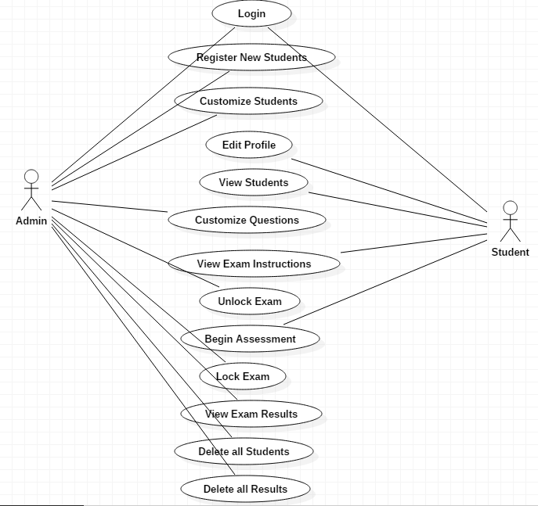

1. **Activity Diagram for Admin**

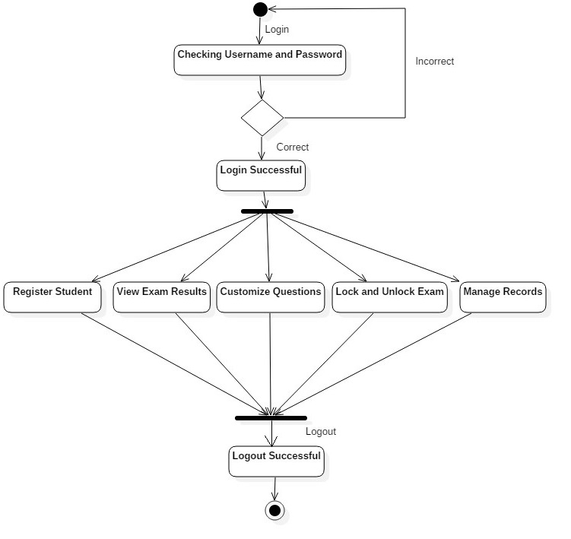

* **Activity Diagram for Student**

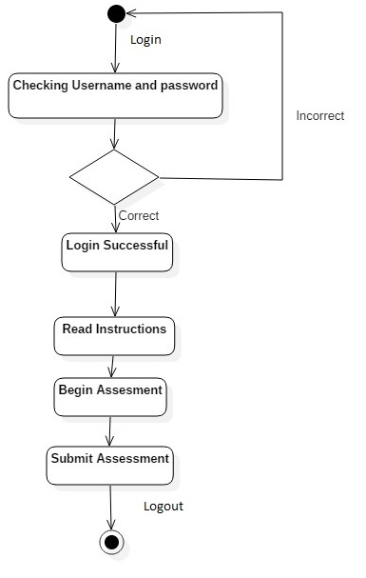

1. **Sequence Diagram**

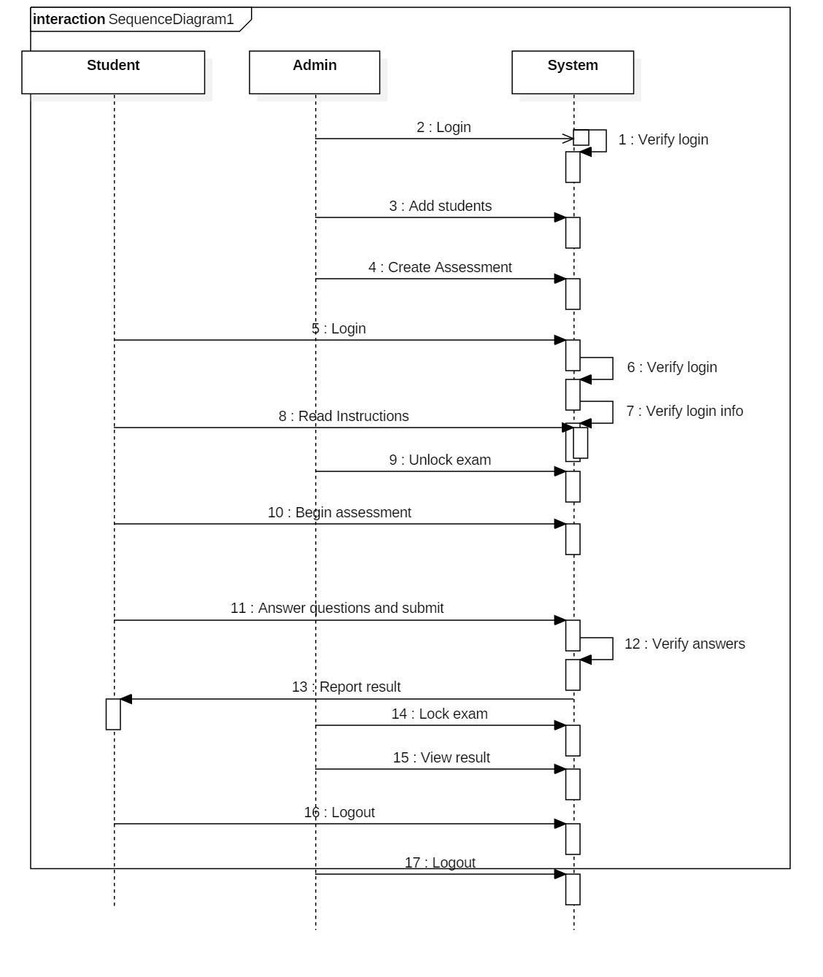

**SYSTEM RECOMMENDATION (SR)**

1. **Transmittal Letter to the client**

Dear Sir/Mam,

In today’s world, one of the main concerns for universities is the Examination system. The manual system of conducting examinations is very cumbersome and time-consuming. It requires the students to be physically present in the examination hall as well as an invigilator to make sure that the examination is conducted in a fair manner. Also, additional time is required for the examiners to check each and every answer sheet. The main purpose of launching our system is to remove the existing flaws in the manual system of conducting exams.

Pace Online Exam System (POES) can be used by Educational Institutes to prepare an exam and save time that will be needed to check papers and prepare mark sheets. It will help the university to test students on the basis of their skills. The main objective of the Pace Online Exam System is to efficiently evaluate the candidate thoroughly through a fully automated system that not only saves a lot of time but also gives fast results. Moreover, there is no restriction that the examiner has to be present while the candidate is taking the test.

A secure login system allows the admin as well as the student to login using a registration ID and password. The ID will be generated only after the admin has registered the student for taking the exam. The Admin has the authority to lock or unlock the exam and it will be available to the student when it is unlocked. Once the student logs in to the system, he can view the examination instructions and then begin assessment. A set of 20 multiple choice questions will be presented to the student, which are randomly chosen from a database of over 100 questions. The student can submit the exam only after attempting all the questions. After submitting, the result would be displayed with details of which questions were right or wrong. The student can re-attempt an exam but only after the admin has allowed access for the same.

Today, most of the universities or institutes are conducting exams online to be a part of the fast growing world. Online Examination System covers almost all type of problems faced by a university or institute while conducting examinations. Hence, it is not only reliable and flexible but also time-efficient.

We would strongly recommend that you implement our system in your university and experience the benefits by using this automated system.

Regards,

Students of Pace University

1. **Executive Summary**

* **Description of problems**

The manual system of writing examinations, which has been ongoing for decades, may not be pleasing for use because of the problems usually associated including examination venue capacity constraints, lack of comfort for examination candidates, delay in the release of results, examination malpractices, cost implication of printing examination materials and human fault. It is not only time-consuming and tedious, but cumbersome, hence there is a need for a better, faster and more reliable means of examining students.

* **Description of the proposed solution**

An online examination system is an application that allows an institution conduct examination via the Internet. This system makes it easier for examiners to conduct exams and collate results. The application provides the faculty the opportunity to conduct online examination anywhere and at any time. Moreover, there is no need to wait for the result as it is automatically generated by the server.

* **Summary of cost/benefit of the proposed solution**

|  |  |
| --- | --- |
| **Tangible Benefits** | |
| **Category** | **In $US** |
| Cost reduction or avoidance | $ 3,500.00 |
| Error reduction | $ 3,500.00 |
| Increased flexibility | $ 8,500.00 |
| Increased speed of activity | $ 9,500.00 |
| Improvement in management planning and control | $ 25,000.00 |
| Other | $ 200.00 |
| **Total Tangible Benefits** | **$ 50,200.00** |
|  |  |
| **Tangible One-Time Costs** | |
| **Category** | **In $US** |
| Development costs | $ 19,000.00 |
| New hardware | $ 14,000.00 |
| New software | $ 6,000.00 |
| User training | $ 3,500.00 |
| Site preparation | $ 200.00 |
| Other | $ 10.00 |
| **Total Tangible One-Time Costs** | **$ 42,710.00** |
|  |  |
| **Tangible Recurring Costs** | |
| **Category** | **In $US** |
| Application software maintenance | $ 20,000.00 |
| Incremental data storage required | $ 3,000.00 |
| Incremental communications | $ 4,000.00 |
| New software or hardware leases | $ 300.00 |
| Supplies | $ 500.00 |
| Other | $ 20.00 |
| **Total Tangible Recurring Costs** | **$ 27,820.00** |

It can be seen from the above cost/benefit analysis that the benefits of the proposed system outweigh the costs. If the organization implements this system, it does not need any additional hardware resources as well as it will be saving a lot of time.

* **Implementation time frame of proposed solution**

The entire system took 4 months for planning and implementation. Refer the Project Schedule (Appendix D- Gantt chart)

1. **Detailed Results of Analysis**

Refer Appendix A- Systems Proposal (SP)

Appendix B- Business Analysis (BA)

Appendix C- Systems Analysis (SA)

1. **Systems Analyst Recommendation**

As a Systems Analyst, I would strongly recommend you to implement the Pace Online Examination System in your University as it is both technically and economically feasible. It is a reliable and portable system that reduces the overhead of manual examination techniques. Analysis will be very easy in proposed system as it is automated. Moreover, it is very secure as there are no chances of leakage of question paper as it is dependent on the administrator.

1. **Proposal Summary**

As discussed, the Pace Online Examination System is a platform beneficial for both the university as well as the students. It is an attempt at removing the flaws of the traditional systems of conducting exams. It is reliable, flexible as well as time efficient and displays accurate results in a short span of time. Hence, it is highly recommended to implement this system in the university.

**REFERENCES & WORKS CITED**

# Scott Tilley & Harry J. Rosenblatt, *Systems Analysis and Design (Shelly Cashman Series)* 11th Edition, ISBN-13: 978-1305494602

# Zhao Qiao-fang & Li Yong-fei, “*Research and Development of Online Examination System”* Published by Atlantis Press, Paris, France

# Deepankar Vishwas Kotwal, Shubham Rajendra Bhadke, Aishwarya Sanjay Gunjal, Puspendu Biswas, “*ONLINE EXAMINATION SYSTEM*”, International Research Journal of Engineering and Technology (IRJET), Volume: 03 Issue: 01 | Jan-2016

# Nicholas A. Omoregbe, Ambrose A. Azeta, Adewole Adewumi, Ajayi O. Oluwafunmilola, “*IMPLEMENTING AN ONLINE EXAMINATION SYSTEM”*, Covenant University (NIGERIA)